- Copy ‘Carvera-3Axis.con’ and ‘Carvera-4Axis.con’ to the ‘C:\Program Files\Carveco\postp’ directory;
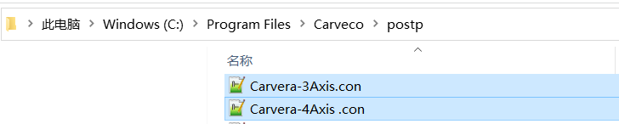

- For 3-axis machining, please select the ‘Carvera-3Axis.con’ post-processing. For 4-axis machining, please select the ‘Carvera-4Axis.con’ post-processing.
